Wapping High Street – AM Peak Eastbound

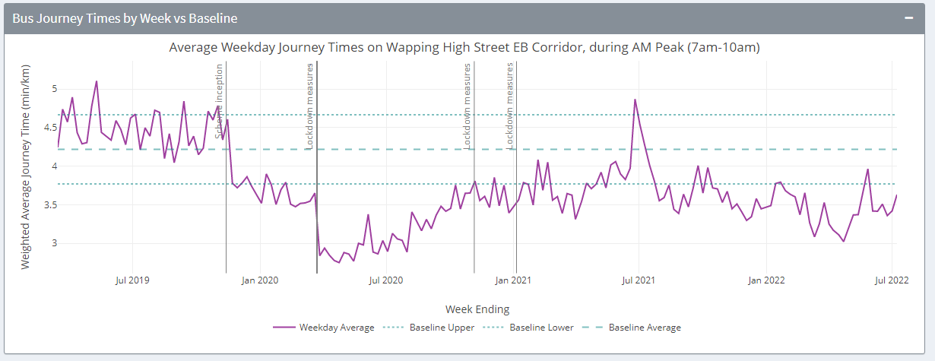

Wapping High Street – PM Peak Eastbound

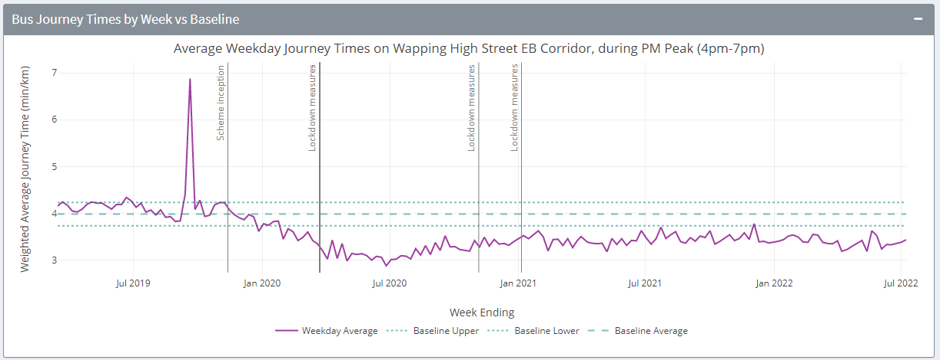

Wapping High Street – AM Peak Westbound

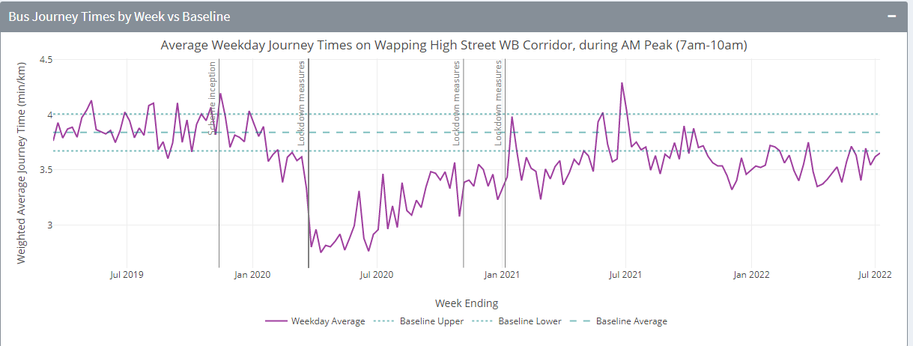

Wapping High Street – PM Peak Westbound

